Will a Soaring Federal Debt, Over Spending Consumers, and Bond Vigilantes Bring on the Recession?

Ernie Goss, Ph.D.

In December 2022, 75% of economists surveyed by the National Association of Business Economics predicted a 2023 recession. Furthermore, the yield curve, which is equal to long-term interest rates minus short-term interest rates, has now been negative for 15 straight months due to the Federal Reserve (Fed) aggressively raising short interest rates above long-term rates. This is the longest period on record of a negative yield curve without a recession. Furthermore since 1955, an inverted yield has preceded all 10 recessions. Have economist and the yield curve lost their predictive punch?
Contrary to this gloomy outlook from economist naysayers and the yield curve, the U.S. economy added 1.54 million jobs and expanded GDP at an annualized 2.0% pace in the first half of 2023. Placing more nails in the 2023 recession coffin, the Atlanta Federal Reserve’s GDPNow model estimates third quarter GDP growth will come in at a very healthy 5.4%. And the October 2023 retail sales report showed that the U.S. consumer is spending at a breakneck pace with September 2023 retail sales advancing by 0.7% from the previous month. Even after subtracting out inflation for the month consumer spending on retail items expanded at a healthy 0.4% for the month. Thus, rapid expansions in GDP, consumer spending, and jobs indicate no 2023 recession. Were economists and the yield curve wrong, or just early?
But why no 2023 recession? Between the beginning of the pandemic in Q1, 2020 and Q3 2023, the Federal Reserve boosted the nation’s money supply by 40% and the federal government increased the national debt from $22.7 trillion to $30.9 trillion. Both actions flooded the consumer with spending power. But the “pig is in the python” as recent the dollar inundation is reversed pointing to an economic downturn as early as the first quarter of 2024. The following will vacuum a large portion of the earlier excess spending:
- 40 million student borrowers must begin loan repayment starting October 1.
- Credit card debt rose between Q1 and Q2 of 2023 to a record high $1.03 trillion thus taking away punch bowl from the consumer spending bash.
- Auto loan payments and monthly mortgage payments are skyrocketing thus cooling consumer revelry.
- The Federal Reserve has begun reducing the green backs in the hands of consumers.
Table 1 shows the extent of this exploding debt emphasizing the impending economic pain for consumers. Will bond vigilantes discipline this overspending?
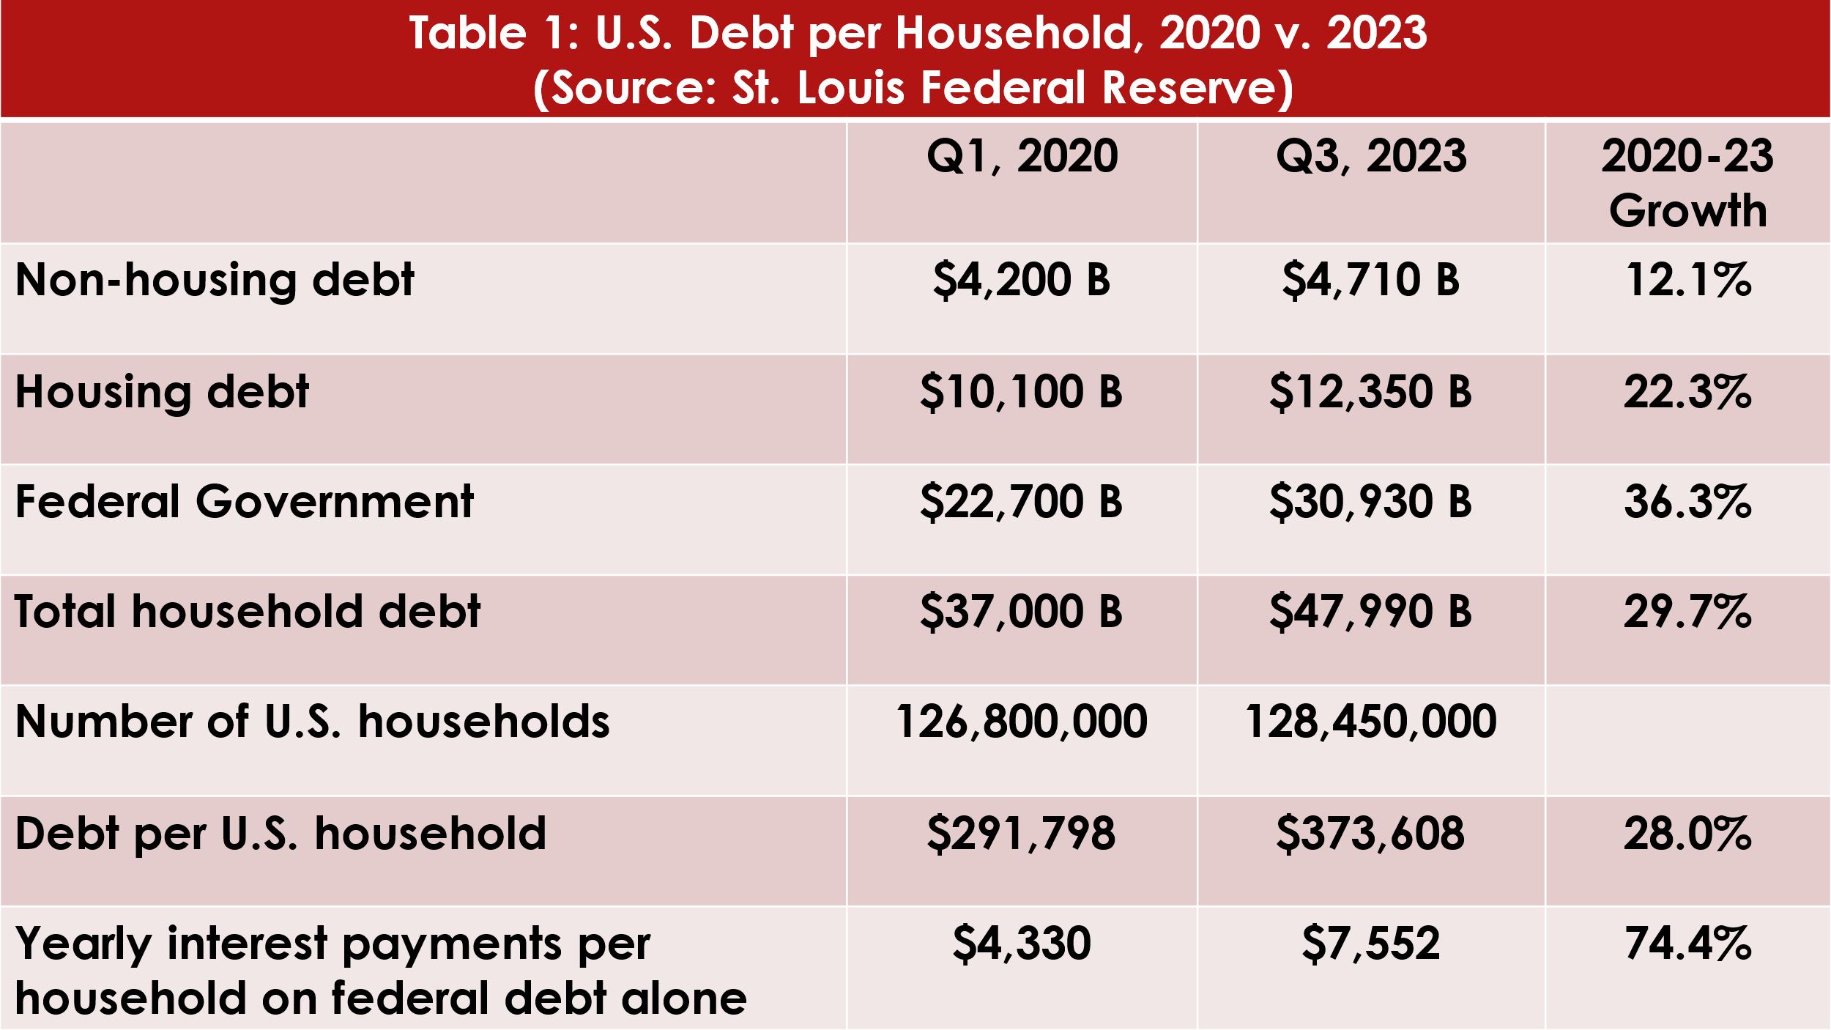
Bond Vigilantes Slam Politicians, and Home Buyers:
Are You Next?

The soaring federal debt has signaled to bond buyers that economic trouble is on the horizon. In the 1980s, Ed Yardeni, president of Yardeni Research, coined the term bond vigilantes referring to investors who protest massive federal deficits by selling off bonds, increasing bond supplies, and pushing yields (interest rates) higher. That is, in today’s financial markets, bond investors see massive federal deficits, record consumer debt, and a Federal Reserve selling bond holdings (i.e. quantitative tightening), and react by fleeing bond investments and boosting yields on U.S. Treasury bonds. Since the early stages of the pandemic, the magnitude of the bond vigilante impacts has been expanding with resultant lower bond prices and soaring yields (interest rates).
Figure 1 shows the relationship between U.S. Treasury bond yields and mortgage rates. Using regression analysis, it was concluded that every 1% increase in U.S. Treasury yields results in 1.01% increase in U.S. 30-year mortgage rates. Since January 2023 U.S. Treasury yields have risen 0.76 percentage points while U.S. 30-year mortgage rates have expanded 0.84 percentage points. If the 10-year Treasury rises to 5.0%, as expected by bond guru Bill Gross, the 30-year mortgage rate will top 8.3% (highest since June 2000).
This has pushed the interest costs on automobile and home loans and produced two years of record losses for retirees and others with investments in bond mutual funds. In fact, due to rising bond yields, Bill Gross expects a record third year of losses for bond investors. On the positive side, it is forcing D.C. politicians to face the problems of soaring federal budget deficits, $2 trillion in fiscal 2023, with federal interest costs soaring above defense sending and approaching $1,000 billion. D.C. politicians have brought its citizens “War-Time Deficits in a Peace-Time Economy.” The accompanying chart shows clearly the impacts of these rising bond yields on mortgage rates.
According to data from the St. Louis Federal Reserve, the median price of a U.S. home has rocketed from $322,600 in Q1, 2020 to $416,100 in Q2, 2023. Soaring housing prices and mortgage rates mean that the monthly payment on the median home with no down payment has soared from $1,440 in March 2020 to $3,083 in October 2023 eating up 40% of consumer income today compared to a historical average of 30%. Will the residential housing market, and an over debt burdened consumer be the source of another U.S. recession? If so, blame overspending D.C. politicians, U.S. consumers, and bond vigilantes.

